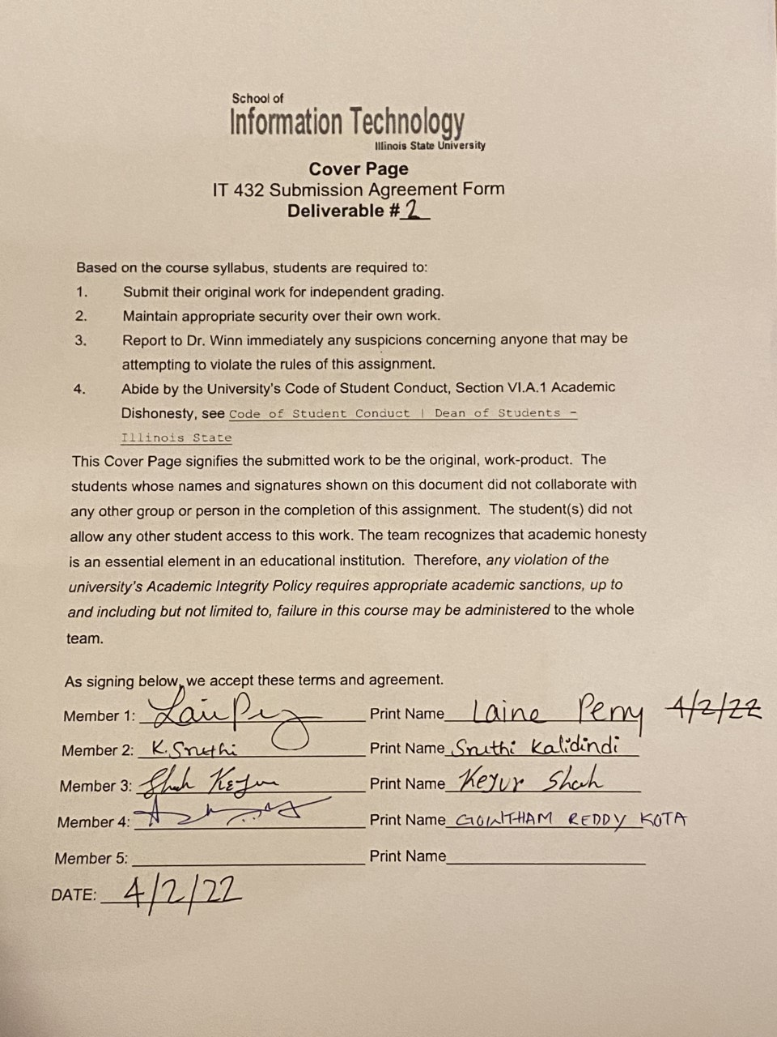

**Table of Contents**

**1. Purpose** **3**

**2. Scope of Project** **3**

2.1 Review of Current Business Functions: Illustrated by Figures 1 - 7 3

2.1.1 Level Context Processes: 3

2.1.2 External Entities 3

2.1.3 Current Data Storage: 4

2.2 Review Processes 6

2.2.1 Level 0 Processes w/ Subprocesses 6

2.3 Introduce Future Business Functions: Illustrated by Figures 8 - 14 8

2.3.1 Level Context Processes: 8

2.3.2 External Entities 8

2.4 Future Processes 9

2.4.1 Level 0 Processes w/ subprocesses 9

**3. As-is Business Models** **12**

**4. To-be Business Models.** **16**

**5. To-be UML Analysis Diagram** **20**

5.1 Use Case: 20

5.2 Domain/ERD Model 22

5.3 Activity Diagram: 23

**6. Functional Requirements** **25**

**7. Non-functional Requirements** **26**

**8. Non-IT Requirements** **29**

8.1 Personnel 29

8.2 Training Requirements 30

8.3 System Documentation 30

8.4 Organization Chart 30

8.5 Procedures 31

8.6 Test Plans 31

8.7 Additional Requirements 32

**9. Revised Project Budget** **33**

**10. Conclusion** **36**

**Deliverable II: Systems Analysis & Requirement Specifications Report**

# **1. Purpose**

The purpose of this project is to assist Happy Valley Kennel in building an improved system, which will help manage day-to-day operations. The overall goal is to automate their “Reservation and Care System”. After assessing the current system, our team identified the need for a website platform. After presenting the stakeholder with two potential options, the stakeholder selected the SimplyBook package. This package provides a website domain with additional add-on features including powerful business tools in a user-friendly format.

The project’s first objective is to move forward planning the automated system using the selected SimplyBook package. Second, prioritize good customers and pets in an effort to retain good business and avoid less desirable customers. This effort will be aided by the addition of an Operations Manager who can assess visual analytical reports and help better understand the quality of customers. Finally, as an extension of retaining good customers and pets, the third objective is to design a system to maintain health records of pets that come to stay at Happy Valley Kennel.

# **2. Scope of Project**

## **2.1 Review of Current Business Functions:***Illustrated by Figures 1 - 7*

### 2.1.1 Level Context Processes:

***0.0 Happy Valley Kennel:*** Main process provides care to customer’s pets. Subprocesses include Booking, Customer Management, Supply, Make Payment, and Pet Assignment, which are described in more detail below.

### 2.1.2 External Entities

***Customer:*** External entity owns pet and initiates scheduling an appointment through Reservation Inquiry, provides Pet Care Data during when they drop pet off for scheduled reservation. In return, they sign a contract provided by Happy Valley Kennel, and finally make a payment for service.

***Supplier:*** External entity that receives orders from Happy Valley Kennel Inc. and provides invoice and delivery of requested items.

***Veterinarian:*** External actor that treats pet during scheduled appointments. Provides a service report to Happy Valley Kennel after treatment is complete.

### 2.1.3 Current Data Storage:

***Kennel Log:*** An employee records a visiting pet’s run assignment, food preferences, and medications on the log. The log indicates which direction the run faces, whether its covered, as well as which runs accommodate large dogs. A customer does not have access to this function.

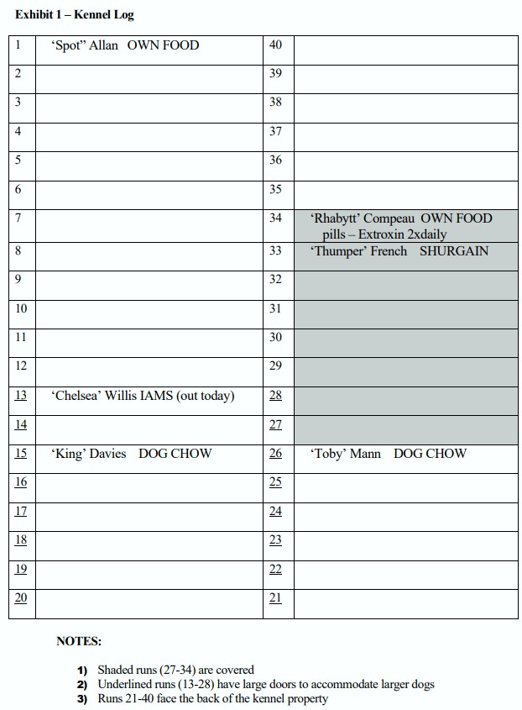

***Kennel Card:*** A recipe card used to manually update basic pet and customer information. Information includes the following: Pet Owner Name, Address, Home Phone, Mobile Phone, Emergency Contact Name, Emergency Contact Phone, Preferred Vet, Vet Contact Information, Date Completed, Pet Name, Pet Date of Birth, Pet Size, Special Requests, Additional Notes, and Medications. During a pet’s stay, an employee makes notes on the Kennel Card. The customer/actor does not have access to this function. Below is an example of what the current Kennel card looks like.

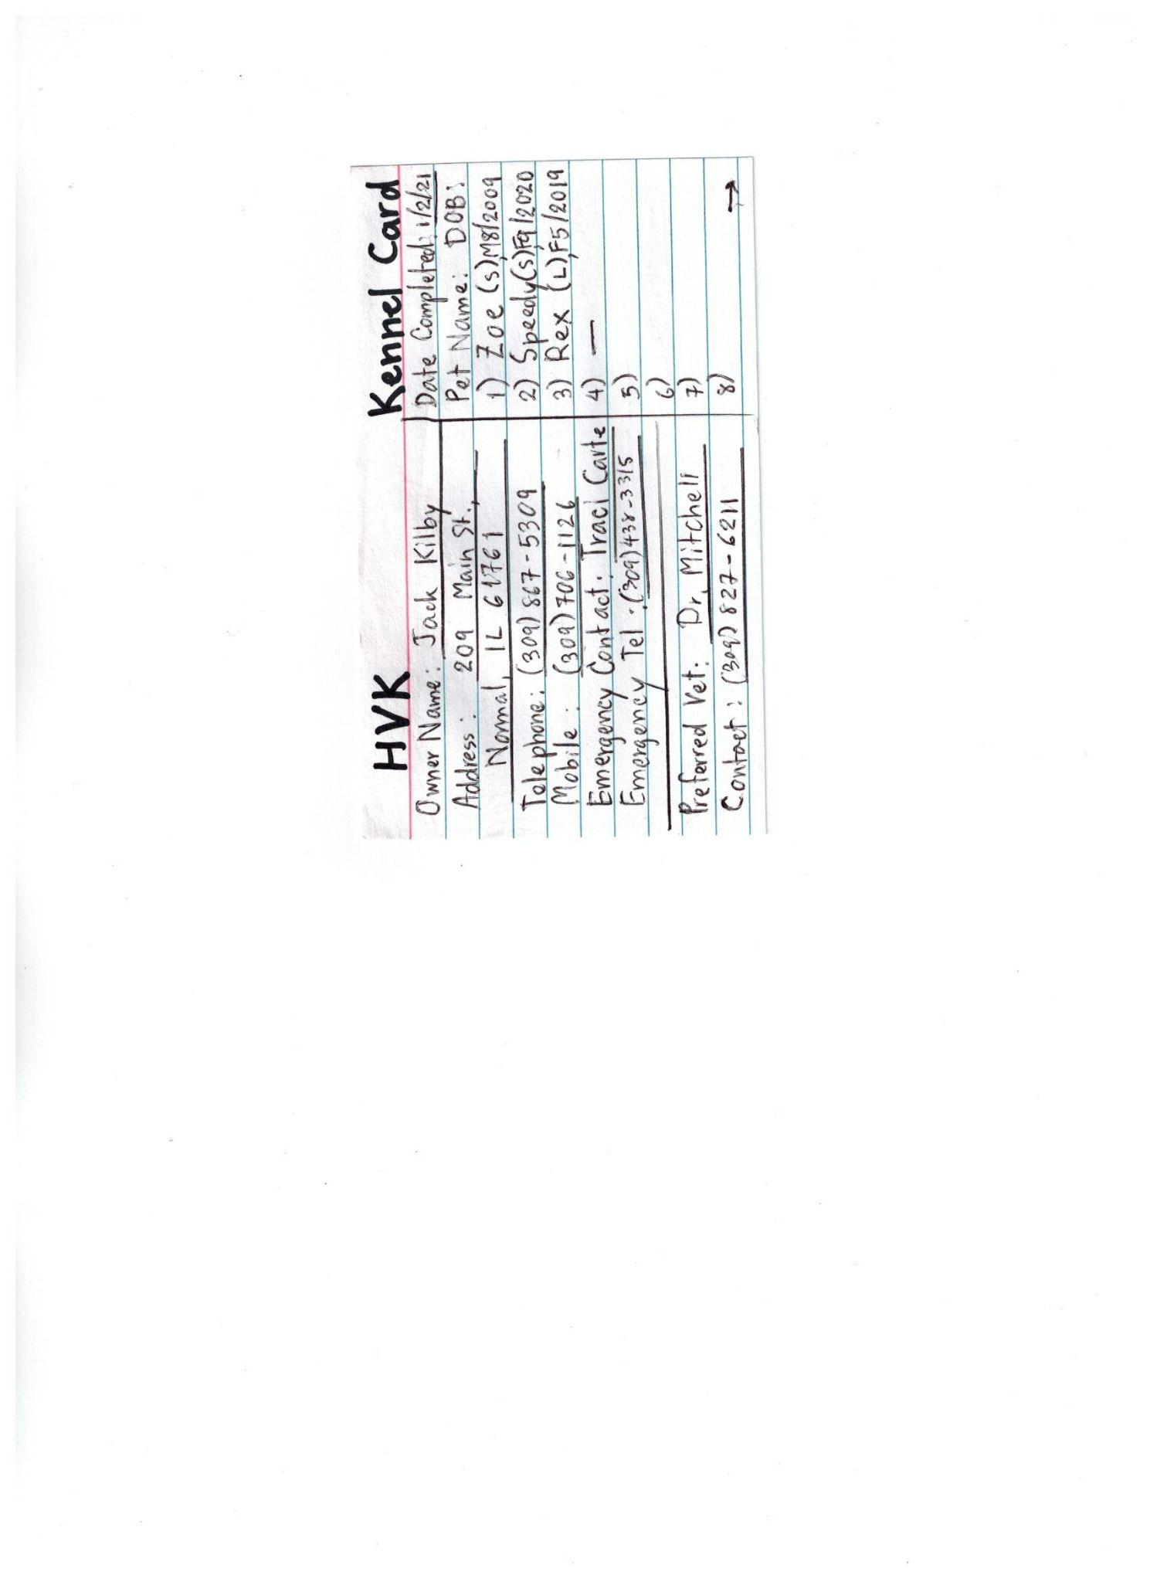

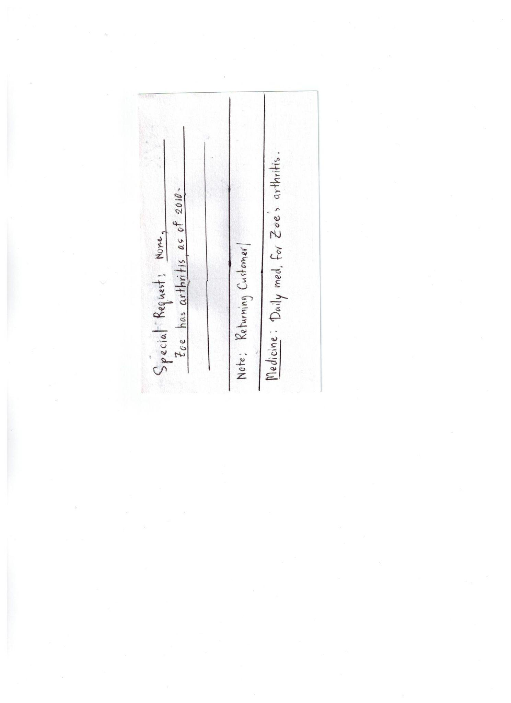

***Billing:*** This represents the current described filing system of Happy Valley Kennel. Based on stakeholder’s description, this involves a filing cabinet that holds invoices, receipts, and financial data for the business.

## **2.2 Review Processes**

### 2.2.1 Level 0 Processes w/ Subprocesses

***1.0 Booking:*** In the current system, approximately 75% of bookings are completed via telephone. During the booking process a Kennel Card is either pulled from files and updated or created on the spot.

***1.1 Check Availability:*** When a customer begins a reservation inquiry via telephone or walk-in, the employee manually checks the Kennel Log for available dates.

***1.2 Create Kennel Card:*** After availability is determined, the employee intakes the customer by creating a Kennel Card.

***1.3 Make Reservation:*** Once availability is confirmed, the requested reservation dates are used to make a reservation. The employee adds the reservation details to the Kennel Log to confirm the booking.

***2.0 Customer Management:*** In the current system, this process is utilized when a pet should require medical attention from an external veterinarian.

***2.1 Schedule Vet Appointment:*** An employee can pull the veterinarian contact information from the Kennel Card. The employee then schedules a vet appointment and brings pet to the scheduled appointment.

***2.2 Record Treatment:*** Once the appointment is over, the vet provides a service report so the employee can properly record the received treatment. Finally, the treatment data is copied onto the pet’s Kennel Card.

***3.0 Supply:*** In the current System, the co-owner Sally notifies Jim when food supply needs to be replenished. This process describes the procurement process of food supplies for Happy Valley Kennel and involves the external Supplier.

***3.1 Verify Invoice:*** Once order is received by external Supplier, the Supplier delivers products and provides an invoice to Happy Valley Kennel. The owners then verify the invoice by checking received shipment against what they were charged for, and files the order receipt into the Billing data storage.

***3.2 Create Order List:*** Food preference data is collected from customers and kept on the Kennel Log. When supply is low, food preference data is used to create an order list. Once food preferences are compared with the current

***4.0 Pet Assignment:*** During the pet dropoff, the external customer provides pet care instructions to the employee, and the employee checks in customer and assigns pet to the appropriate run.

***4.1 Record Check-In:*** Pet care data is provided by the external customer at the time of drop-off. Pet Drop-off represents the time recorded at check-in. That time is then recorded and used on the contract and customer details are updated on the Kennel Card.

***4.2 Make Run Assignment:*** Using the pet’s Kennel Card, the employee uses the identified run preferences listed on the Kennel Card to decide which run the pet should be assigned to. Run preferences can be based on characteristics such as pet size, whether they bark often, or if the run is covered. Once decided, the employee adds the pets details to the week’s Kennel Log.

***4.3 Contract Management:*** Once the guest is checked in, a contract is drawn for the external customer to sign. Information and customer data on the contract is directly transferred by hand from the Kennel Card to the contract. The payment is calculated on the contract and is then provided to the customer. Once the customer signs the agreement, a copy of the contract is provided to the customer.

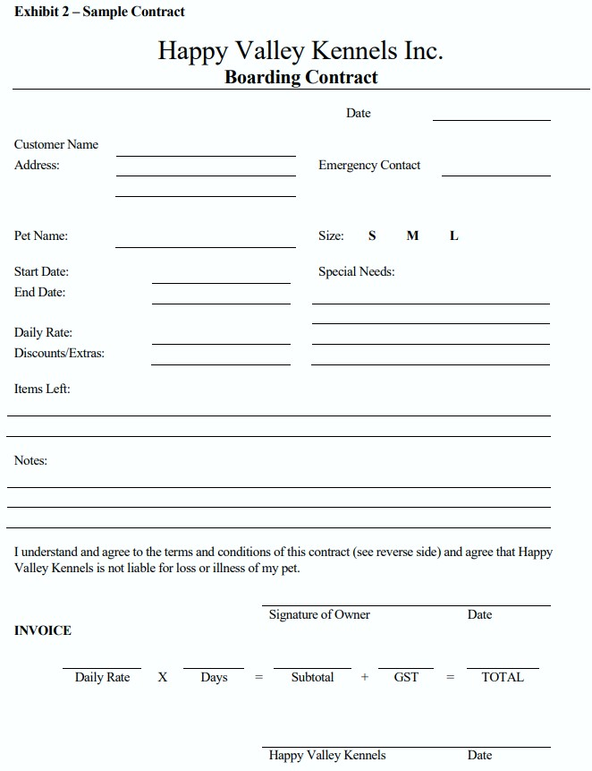

**5.0 Payment System:** The current system has a separate payment process outside of the booking system. The external customers pays for the service provided by Happy Valley Kennel.

**5.1 Record Payment:** The external customer provides payment to the employee. The employee then records payment details such as payment type, check number, and amount. These transaction details are then verified.

**5.2 Verify Transaction:** The payment received by the external customer is used to verify the amount paid is the amount owed. Once verified, the receipt is filed into the billing data storage.

## **2.3 Introduce Future Business Functions:** *Illustrated by Figures 8 - 14*

### 2.3.1 Level Context Processes:

***0.0 Happy Valley Kennel, Inc:*** Process provides care to customer’s pets. Main process includes automated sub-processes described in Level 0 section including Booking, Customer Management, and Reporting. Other manual processes include Pet Assignment and Supply. The previous system also had a separate Payment process. In the new system, the payment process is merged with the Booking process. The following describes the future system and its new components.

### 2.3.2 External Entities

***Customer:*** External entity owns pet and initiates scheduling an appointment, but interacts with the system in a new way. External customer provides pet care data, payment, and reservation inquiry through online means that will be described in depth below. The customer no longer signs a physical contract, but receives an email confirmation once the reservation is booked. The customer continues to drop-off pets.

***Supplier:*** External entity remains the same *(see Supplier in Current Business Functions).*

***Veterinarian:*** External entity remains the same *(see Veterinarian in Current Business Functions).*

## **2.4 Future Processes**

### 2.4.1 Level 0 Processes w/ subprocesses

***1.0 BOOKING:***The customer books a reservation via the new Happy Valley Kennel website. The customer requests to make an appointment and is prompted to create an account. If the customer already has an account, then they can go directly to the booking page. Bookings can be made 24/7 via the website.

***1.1 Access Account:***A customer’s account includes data that was previously stored on the Kennel Card. This can be referred to a the “Virtual Kennel Card” to assist employees when attempting to find data on customers in the online system. However, the Virtual Kennel Card is the same as a customer’s profile. When a customer creates an account they will fill out an intake form. The account will be password protected. The user can update personal information as well as pet information or schedule a booking.

**Intake Form Description:** Online HTML form used to collect the following information:Customer name, address, home phone number, mobile phone number, emergency contact, emergency phone number, preferred veterinarian, vet phone number, date completed, pet name, pet size, preferred run assignment, and pet date of birth. The account also includes special requests field, notes field, and medicine field. This form then uploads this information to the customer’s profile inside the Cloud Database data storage, which eliminates the need for a Kennel Card.

**Changes To Note:** The “Pet Care Data” has been moved to its own dataflow **(see Figure ##)** since this is now received during the initial booking through the online intake form, rather than by word of mouth at check-in.

**Update Customer Profile:** After a customer has created an account and completed the initial intake form, they may return to their account and make edits to their profile.

**Update Pet Health Status:** Prior to every booking, a customer is prompted to update pet health history, which includes all treatments, conditions, medications, and procedures for the pet. Anytime the user accesses their account, they are able to update their pets health information. In the event a pet must be taken to the vet, this information can be pulled and provided to the veterinarian.

***1.2 Schedule Appointment:***The customer can schedule an appointment online by accessing their account and navigating to the booking page.

**Reservation:** The SimplyBook Scheduler provides the customer with the ability to make a reservation online. Once a customer is on their account, they may use a request form to schedule an appointment. The SimplyBook Scheduler will then pull the available dates from the cloud database and provide the customer only with available dates. Notice in Figure 1, how the bolded dates indicate availability, while the faded dates indicate the service is full.

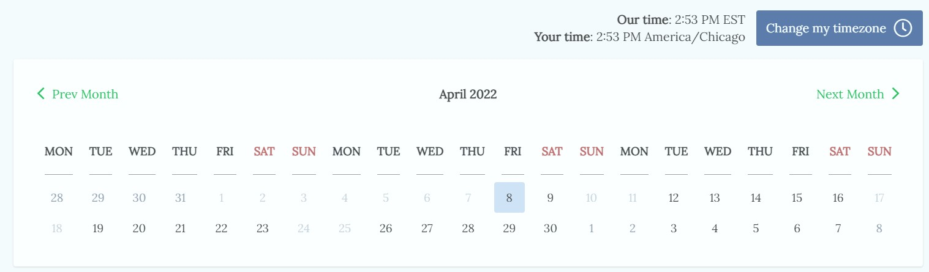[1]

**Terms of Service:** Instead of a physical contract that is signed at pet drop-off, the contract is accepted via the Terms of Service Condition statement during the online reservation. The customer may read the terms of service and check in agreement if they accept. Once the booking is finalized, the customer will receive an email confirmation including the details of the reservation. Notice in **Figure 10** the data flow “Contract Copy” has been removed.

***1.3 Make Payment:*** Once a customer makes an appointment, they can make their payment through the SimplyBook POS system. The ability to use cash at dropoff is still available. The transaction data is then automatically stored in the Cloud Database that holds all customer related data.

**Select Payment Type:** Customers may choose credit card or PayPal as the form of payment online.

***2.0 CUSTOMER MANAGEMENT:*** In the even that a pet is ill or injured, Happy Valley Kennel may make an appointment with a veterinarian to assist in treatment.

***2.1 Schedule Vet Appointment:***the employee can pull the pet’s associated vet contact information and medical history from the customer’s online profile. Using this data, the employee may schedule an appointment via phone call and can bring a physical copy of the pet’s health history to the veterinarian appointment.

***2.2 Record Treatment:*** Once the treatment is complete, the veterinarian will send an email containing the service report to Happy Valley Kennel. The employee can then attach that report to the customer’s profile and update the pet’s medical history.

***3.0 SUPPLY:*** This system remains mostly unchanged from the current system.

***3.1 Verify Invoice:*** The supplier provides a paper copy of the order invoice. Once the invoice is verified, the order receipt is added to the Billing filing cabinet.

**Changes to Note:** Notice the verifying will be completed by the newly hired Operations Manager.

***3.2 Create Order List:*** Using the cloud database, records can be analyzed in the reporting dashboard to better track food preference data. Once this is compared with the current inventory list, the official order list is created. The order is then placed by the newly hired Operations Manager via telephone to the appropriate supplier.

***4.0 PET ASSIGNMENT:*** This process remains mostly unchanged aside from the implementation of using a cloud database to store information.

***4.1 Record Check-In:***The pet is dropped off at the kennel and the check-in time is recorded on the Scheduler webpage.

***4.2 Make Run Assignment:*** If the customer is a returning customer, run preference can be retrieved to help determine the appropriate run assignment. The pet is assigned and the pet’s details are then added to the cloud database.

***5.0 MAKE PAYMENT:*** This process has been moved inside the booking process. See 1.0 Booking in the Future Automated Section.

***6.0 REPORTING:***In an effort to help retain desirable customers, the reporting process has been added to the Happy Valley Kennel System.

***6.1 Run Customer Reports:*** Using the collected customer trends recorded from the website, the Operations Manager can use the SimplyBook Report Dashboard to run customer behavior reports.

***6.2 Review Visual Analytics:*** Once reports are ready to be reviewed, the Operations Manager may assess and identify customers with positive behavioral trends. The systems analyst team previous identified the following attributes as the criteria for classifying customers:

*Good Customers:*

* + 1. Use services often
    2. Follow through regularly on appointments
    3. Advocate for Happy Valley Kennel to other potential customers
    4. Vaccinates and spays/neuters pet, keeps pet up to date on health

*Poor Customers:*

* + 1. Schedules appointment and does not show up to appointment
    2. Consistently late to pick up pet from kennel
    3. Unfriendly pets or ill-mannered pets that create tension in kennel
    4. Unvaccinated pet, not up to date on health checks
    5. Fails to honor signed contract agreement

**6.3 Assign Loyalty Points:** Once desirable customers are identified, the operations will use the Simplybook Loyalty System Webpage to assign Loyalty Points to those identified customer’s accounts.

**Loyalty Points:** To assist Happy Valley Kennel in retaining and rewarding desirable customers, a loyalty system will be put in place to reward loyal customers. These can be rewarded to customers who consistently book with Happy Valley Kennel, as well as those who keep scheduled appointments. According to Simplybook: “You can allocate some extra loyalty points to your favourite client, and your clients can log in at all times to see the status of their accumulated points.”[2]

# **3. As-is Business Models**

|  |  |
| --- | --- |
| *Figure 1. Context Diagram (As-Is Model)*  *Happy Valley Kennel System* |  |
|  | |

|  |  |
| --- | --- |
| *Figure 2. Diagram 0 (As-Is Model)*  *Happy Valley Kennel System* |  |
|  | |

|  |  |
| --- | --- |
| *Figure 3. Diagram 1.0 (As-Is Model)*  *Booking System* |  |
|  | |

|  |  |
| --- | --- |
| *Figure 4. Diagram 2.0 (As-Is Model)*  *Customer Management System* |  |
|  | |

|  |  |
| --- | --- |
| *Figure 5. Diagram 3.0 (As-Is Model)*  *Supply System* |  |
|  | |

|  |  |
| --- | --- |
| *Figure 6. Diagram 4.0 (As-Is Model)*  *Pet Assignment System* |  |
|  | |

|  |  |
| --- | --- |
| *Figure 7. Diagram 5.0 (As-Is Model)*  *Make Payment System* |  |
|  | |

# 

# **4. To-be Business Models.**

|  |  |
| --- | --- |
| *Figure 8. Context Diagram (To-Be Model)*  *Happy Valley Kennel System* |  |
|  | |

|  |  |
| --- | --- |
| *Figure 9. Diagram 0 (To-Be Model)*  *Happy Valley Kennel System* |  |
|  | |

|  |  |
| --- | --- |
| *Figure 10. Diagram 1.0 (To-Be Model)*  *Booking System* |  |
|  | |

|  |  |
| --- | --- |
| *Figure 11. Diagram 2.0 (To-Be Model)*  *Customer Management System* |  |
|  | |

|  |  |
| --- | --- |
| *Figure 12. Diagram 3.0 (To-Be Model)*  *Supply System* |  |
|  | |

|  |  |
| --- | --- |
| *Figure 13. Diagram 4.0 (To-Be Model)*  *Pet Assignment System* |  |
|  | |

|  |  |
| --- | --- |
| *Figure 14. Diagram 6.0 (To-Be Model)*  *Reporting System* |  |
|  | |

# **5. To-be UML Analysis Diagram**

## **5.1 Use Case:**

***Description:*** The following diagram illustrates the to-be system for Happy Valley Kennel using a Use Case Diagram. Although the system also includes Pet Assignment and Supply, the Use Case only includes the automation within the system. There are two actors in this diagram: the customer and employee. A customer actor’s interaction with the system is through the Booking subsystem, while the employee’s interaction can be through either the Customer Management or Reporting subsystems.

A customer can interact by making a payment, booking an appointment, creating an account, or simply accessing their account. All of these interactions take place within the automated booking system, which is why they are placed inside the automation border.

|  |  |
| --- | --- |
| *Figure 13. To-Be Use Case Diagram*  *Automated System* |  |
|  | |

## **5.2 Domain/ERD Model**

***Description:*** The Data Flow Diagrams above show a singular cloud database that holds customer data. WIthin that cloud database holds the following tables of data: Payment, Customer, Account, Run, Pet, Appointment, and Confirmation. The SimplyBook system provides a singular system that can hold multiple data tables that are linked to one another.

|  |  |
| --- | --- |
| *Figure 14. To-Be Entity Relationship Diagram* | *Automated System* |
|  | |

## **5.3 Activity Diagram:**

***Description:*** The activity diagram illustrates the booking system. A customer will access the new Happy Valley Kennel website. If they are an existing customer, they may schedule an appointment, otherwise, they must first create an account. Once they schedule an appointment, the customer must decide if they would like to update their profile information. All customers during the booking process are required to update their pet’s health status to ensure their medical data is up to date when they arrive for their appointment. Once updated, the customer is moved to the payment webpage, where they will make a payment based on the days they have reserved. Finally, the customer receives a confirmation, and the booking process ends.

|  |  |
| --- | --- |
| *Figure 14. To-Be Entity Relationship Diagram*  *Automated Booking System* |  |
|  | |

# **6. Functional Requirements**

***Description:*** The following are the non-functional requirements of the new system for Happy Valley Kennel. A requirement is a statement that identifies the needs of a system to solve a problem for the user. In short, functional requirements describe what the system should do, while non-functional requirements describe how the system should do it.

The functional requirements are divided into three categories based on the primary scope of the project. The scope communicated with the stakeholder includes automating the reservation/booking system, automating the pet health records, and using visual analytics to assist in retaining desirable customers. Note that to aid in visual clarity, each system is color coded with similar colors as coded on the DFD.

|  |  |
| --- | --- |
| FR | *Requirement Description* |
| ***BOOKING SYSTEM*** | |
| **F1** | The customer shall have an account. |
| **F2** | The customer shall be able to make a payment. |
| **F3** | The customer shall book an appointment. |
| **F4** | The booking system should accept payment. |
| **F5** | The booking system shall allow customers to view available dates. |
| **F6** | The booking system shall generate a terms of service agreement. |
| **F7** | The booking system should record scheduled reservations. |
| **F8** | The booking system shall provide reservation confirmation. |
| **F9** | The booking system shall secure customer data. |
| **F10** | The system shall be reliable. |
| ***PET HEALTH*** | |
| **F7** | The system shall store pet health history. |
| **F8** | The system shall store preferred veterinarian contact information. |
| **F9** | The customer management system shall record treatment. |
| ***RETAINING GOOD CUSTOMERS*** | |
| **F10** | The system shall store customer data. |
| **F11** | The reporting system shall present customer trends. |
| **F12** | The reporting system shall reward loyal customers. |

# **7. Non-functional Requirements**

***Description:***The following table includes the non-functional requirements and identifies which functional requirements it is associated with. The non-functional requirements also include a General Operation section that lists the requirements needed to keep the system running, but may not necessarily fall into any of the Functional Requirement categories (Booking, Pet Health, or Reporting).

|  |  |  |
| --- | --- | --- |
| *FR* | *NFR* | *Non-Functional Requirement Description* |
| BOOKING SYSTEM | | |
| ***Usability*** | | |
| F1 | NF01 | The customer shall access their online account through the SimplyBook Website |
| F1 | NF02 | The customer shall create an online account using the SimplyBook Website. |
| F2 | NF03 | The booking system shall accept Credit Cards as a form of online payment. |
| F2 | NF04 | The booking system shall accept PayPal as a form of online payment. |
| F3 | NF05 | The customer shall use the Appointment Request Form to make a reservation. |
| F5 | NF06 | The booking system shall pull available dates from the SimplyBook Scheduler. |
| ***Performance*** | | |
| F10 | NF07 | The system web page should load within 6 seconds of request on average. |
| F10 | NF08 | The booking system shall operate on Chrome Web Browser. |
| ***Reliability*** | | |
| F3 | NF09 | The booking system shall accept online customer bookings 24/7. |
| F5 | NF10 | The employee shall be able to view bookings through the SimplyBook Schedule Calendar. |
| F7 | NF11 | The system shall store reservations in the cloud database. |
| F8 | NF12 | The system shall generate an email containing reservation data to confirm each booking. |
| F10 | NF13 | SimplyBook shall maintain a 99.9%[3] uptime. |
| ***Security*** | | |
| F9 | NF14 | Data shall be encrypted when stored in the database daily to prevent data loss. |
| F9 | NF15 | The booking system shall be backed up on a cloud database. |
| F9 | NF16 | The customer shall use an encrypted password to access their online account. |
| ***Supportability*** | | |
| F2 | NF17 | The system will allow payment through the Point of Sale (POS) system. |
| F6 | NF18 | The booking system will provide customers with a checkbox to accept the terms of service. |
| PET HEALTH | | |
| ***Usability*** | | |
| F9 | NF19 | The employee shall update the pet’s treatment to the customer profile. |
| F10 | NF20 | The system shall collect pet health information via the online intake form. |
| ***Reliability*** | | |
| F7 | NF21 | The system shall record pet medical history data on the cloud database. |
| F8 | NF22 | The system shall store preferred veterinarian contact information in the cloud database. |
| F9 | NF23 | The customer management system shall attach Service Reports to the customer’s online account. |
| RETAINING GOOD CUSTOMERS | | |
| **Usability** | | |
| F11 | NF24 | The system shall present customer trends on the Reporting Dashboard. |
| F12 | NF25 | The system shall use loyalty points to reward desirable customers. |
| F12 | NF26 | Loyalty points shall be rewarded through the Loyalty System Webpage by the Operations Manager. |
| **Performance** | | |
| F11 | NF27 | The reporting dashboard shall update graphics within 2 seconds of viewing the dashboard. |
| **Reliability** | | |
| F10 | NF28 | The system shall store customer data on the cloud database. |
| F11 | NF29 | The system shall track customer trends on the cloud database. |
| **Security** | | |
| F9 | NF30 | The reporting system shall be restricted to only allow admin access. |
| F10 | NF31 | The reporting system shall provide an automated data backup daily. |
| GENERAL OPERATIONS | | |
| ***Supportability*** | | |
|  | NF32 | The system shall have a help assistant live chat[4] available 24 hours a day Monday through Friday. |
| NF33 | The system requires the annual premium subscription renewal from SimplyBook. |
| ***Implementation*** | | |
|  | NF34 | The system shall be able to import legacy data from an excel .csv file. |
| ***Design Constraints*** | | |
|  | NF35 | The system shall collect pet health history through the online intake form. |
| NF36 | The system shall use a minimum of 8GB of RAM. |
| NF37 | The system shall run on a computer with at least Intel I7. |
| NF38 | The system shall operate on a PC with internet access. |
| ***Physical*** | | |
|  | NF39 | The system shall be run on a windows PC with access to the internet. |
| NF40 | The system shall have a router to connect devices to wifi. |
| NF41 | The system shall use between 15,000 kWh to 25,000 kWh per year.[5] |
| NF42 | The system shall use at least 500 gallons of water per month.[6] |
| NF43 | The facility shall maintain an average temperature of 70 degrees fahrenheit. |
| NF44 | The company computer shall be located at the front desk of the facility. |
| ***Internal Interface*** | | |
|  | NF45 | The system shall upload data to the cloud database from a .csv file. |
| NF46 | The system will provide visual analytical reports using SimplyBook. |
| NF47 | The system shall use an HTTPS URL for payment portal. |
| ***External Interface*** | | |
|  | NF48 | The system shall use a Windows 10 interface. |

# 

# **8. Non-IT Requirements**

## **8.1 Personnel**

|  |  |  |
| --- | --- | --- |
| **Personnel Requirements** | | |
| Position Title | Name | Requirements |
| CEO/Co-Owner | Jim Read Sally Read | * Lead in a supervisory capacity at Happy Valley Kennel * Handle large scale decisions for the future direction of the business * Handle financial needs for supply procurement and operations * Expand business ventures as opportunities arise   This position will continue to lead Happy Valley Kennel, but will have the opportunity to step back from the operations side of the business. |
| Operations Manager | TBD | * Handle all day-to-day operations of the new system * Make small-scale decisions that impact day-to-day functions * Analyze customer trends through the new reporting system * Shall have basic IT skills such as Microsoft Office Suite and a background in data analytics   The new system requires Happy Valley Kennel to hire a new Operations Manager to handle all day-to-day operations of the system and its business functions. This will be a new full-time position and will assist in primary functions of running the updated operation. |
| Part-Time Employee: | Jake Smith | * Assist in handling daily tasks to run HVK efficiently * Primary tasks include feeding and letting dogs outside   This role will continue to be a part of the system, but will have a decrease in hours. Due to the updated booking system, there will be a significant decrease in hours spent answering phones and manually updating documents. |

## **8.2 Training Requirements**

Training for all new and current persons will take approximately 4 weeks. This timeline includes 1 week introducing employees to the new technology and creating profiles. There will be an adjustment period of 2 weeks for users to become accustomed to logging in and updating information. Finally, a final fourth week to ensure the employee’s understanding of the system’s full capabilities and features, as well as for the Operations Manager to pull the first Monthly Reports from the system.

## **8.3 System Documentation**

SimplyBook maintains an extensive record of videos and documentation to answer any questions an employee or user may have regarding the new system. The Features and Integrations Webpage[7] provides a list of all possible features and widgets that may be added as well as explanations on how to use them.

## **8.4 Organization Chart**

|  |  |
| --- | --- |
| *Figure 16. Organization Chart*  *Happy Valley Kennel* |  |
|  | |

## **8.5 Procedures**

***Power Outage:*** If the Happy Valley Kennel facility experiences a power outage, the SimplyBook website is capable of running on a mobile tablet. The mobile tablet or mobile smart phone will provide a sufficient interim solution until the power outage is resolved.

***SimplyBook Failure:***SimplyBook has a 99% uptime rate, so failure is very unlikely. However, in this instance, Happy Valley Kennel can revert to manual processes such as tracking bookings in an excel worksheet. Once SimplyBook resumes functioning, the admin may upload the .csv file of new or returning customers into Happy Valley Kennel’s cloud database, and SimplyBook will automatically update the database. During failure, the Operations Manager may contact SimplyBook’s 24/7 customer service.

***Database Failure:*** If the system is not correctly fetching data, the system shall keep important data on an offline harddrive to avoid any data loss.

***Physically Damaged Hardware:*** Since Simplybook maintains a fully online database, technology failure such as a broken computer will not corrupt data collected. New hardware may need to be purchased, but the data, website, and schedule will remain uncorrupted and still be accessible with the correct login and password.

## **8.6 Test Plans**

|  |  |  |
| --- | --- | --- |
| **FR** | **TP#** | ***Test Plan Description*** |
| *Booking System* | | |
| F1 | TP01 | *Create a test account using a non-admin account on the customer-end.* |
| F2 | TP02 | *Test payment portal by conducting a small payment transaction on the test account.* |
| F3 | TP03 | *Test appointment function by logging into the created test account and working through the scheduling process.* |
| F4 | TP04 | *Conduct TP02, then log into the admin account to ensure system accepted payment.* |
| F5 | TP05 | *While conducting TP03, ensure that only dates that are available for booking are shown.* |
| F6 | TP06 | *While scheduling an appointment using the test account, ensure the system prompts the customer for the terms of service agreement.* |
| F7 | TP07 | *Once test reservation is made, log into the admin account to ensure reservation is shown on the SimplyBook Calendar.* |
| F8 | TP08 | *Once test reservation is made, check the test account’s email for a confirmation message of the test appointment.* |
| F9 | TP09 | *Attempt to log into the admin account with the incorrect password or username and ensure that the system does not allow entry.* |
| F10 | TP10 | *Conduct tests multiple times to ensure the system continues the same behavior, and does not deviate from norm to ensure reliability.* |
| *Pet Health* | | |
| F11 | TP11 | *View the customer profile listing to ensure pet data is linked to each customer.* |
| F12 | TP12 | *Review the test customer profile to view the input preferred vet’s contact information.* |
| F13 | TP13 | *Add a test service report to the test account and ensure information can be updated on the pet’s profile.* |
| *Retaining Good Customers* | | |
| F14 | TP14 | Check the data store to view customer data. |
| F15 | TP15 | Review the reporting dashboard to review customer trends. |
| F16 | TP16 | Use the loyalty points system webpage to assign the test customer with loyalty points. |

## **8.7 Additional Requirements**

|  |  |
| --- | --- |
| **System Installation Requirements** | |
| Operating System Installation | Windows (10,11) |
| Web Browser | Google Chrome |
| Management System | Oracle |
| **Hardware Requirements** | |
| RAM | Minimum 8GB or higher |
| HDD | Minimum 50 GB free space |
| Processor | Intel I7 |

# 9. Revised Project Budget

**DIRECT COSTS BREAKDOWN:**

***SimplyBook Package:*** The SimplyBook package will cost between $600 per year. This will cover costs for features including booking system, website, payment system, mobile application capabilities.

***Operations Manager:*** The proposed new hire will primarily act as an office manager with basic IT and data skills. With the expected data background, Happy Valley Kennel should expect to pay a higher than average salary for this position. Therefore, the salary is expected to be around $70k. The new hire will be responsible for running the new automated operations.

***Systems Analysts:*** At a rate of $45/hour for a team of 4, the total estimated cost will be around $25,600 for the duration of our work over 4 weeks.

|  |  |  |  |  |
| --- | --- | --- | --- | --- |
| **Year** | **SimplyBook Package[8]** | **Operations Manager[9]** | **Systems Analysts[10]** | **Total** |
| 0 | $600 | $70,000 | $25,600 | $96,200 |
| 1 | $600 | $70,000 | – | $69,700 |
| 2 | $600 | $70,000 | – | $69,700 |
| 3 | $600 | $70,000 | – | $69,700 |
| 4 | $600 | $70,000 | – | $69,700 |
| 5 | $600 | $70,000 | – | $69,700 |
| 6 | $600 | $70,000 | – | $69,700 |
| 7 | $600 | $70,000 | – | $69,700 |
| 8 | $600 | $70,000 | – | $69,700 |
| 9 | $600 | $70,000 | – | $69,700 |
| 10 | $600 | $70,000 | – | $69,700 |

**Total Cost of Ownership For YEAR 0 Breakdown**

|  |  |
| --- | --- |
| **Expense Category** | **Amount** |
| DIRECT COSTS | |
| Software (SimplyBook) | $600 |
| Operations Manager | $70,000 |
| Systems Analyst | $25,600 |
| INDIRECT COSTS | |
| **Annual Labor costs | $17,500 |
| **Material Costs | $5,000 |
| **Cost of Utilities | $7,000 |
| **Cost of Rent/Mortgage for location | $36,000 |
| **Total** | **$161,700** |

**Total Cost of Ownership Annually YEAR 1 - 9 BREAKDOWN**

|  |  |
| --- | --- |
| **Expense Category** | **Amount** |
| DIRECT COSTS |  |
| Software (SimplyBook)[11] | $600 |
| Operations Manager**[12]** | $70,000 |
| INDIRECT COSTS |  |
| **Annual Labor Costs | $17,500 |
| **Material Costs | $5,000 |
| **Cost of Utilities | $7,000 |
| **Cost of Rent/Mortgage for Location | $36,000 |
| **Total** | **$136,100** |

**Anticipated Benefits**

|  |  |  |
| --- | --- | --- |
| **Benefits/Cost Saving** | **Amount** | **Comments** |
| Increased Efficiency for Part Time Employee | $17,500 | @50% increased |
| Increased Customers | $36,000 | @25% increased[13] |
| Annual revenue | $144,000 |  |
| **Total** | **$198,500** |  |

**Calculations Provided by Stakeholder:**

Monthly Revenue = 22(average fee) * 21(no of kennels) * 24(no of days) =$11,088 - $12,000

After the project, the monthly revenue increases as the kennel is occupied for 30 days of the month.

Monthly revenue = 22(average fee) * 21(no of kennels) * 30(no of days) =$13,860

Increased percentage of monthly revenue =

( Increased Revenue / Provided Revenue by Stakeholder ) * 100

=(13,860 / 11,088 ) * 100 = 125%

There is an increase of 25% in the monthly revenue due to the increased customers from the project.

**RMO Cost Benefit Analysis**

|  |  |  |  |  |  |  |
| --- | --- | --- | --- | --- | --- | --- |
| **Year** | **Discount Factor (11%)** | **Benefits** | **Costs** | **PV Benefit** | **PV Costs** | **Cumulative NPV** |
| Y0 | 1.0000 |  | -$161,700.00 |  | -$161,700.00 | - $161,700.00 |
| Y1 | 0.9009 | $198,500.00 | -$136,100.00 | $178,828.83 | -$122,612.61 | -$105,483.78 |
| Y2 | 0.8116 | $198,500.00 | -$136,100.00 | $161,107.05 | -$110,461.81 | -$54,838.54 |
| Y3 | 0.7312 | $198,500.00 | -$136,100.00 | $145,141.49 | -$99,515.15 | -$9,212.20 |
| **Y4** | **0.6587** | **$198,500.00** | **-$136,100.00** | **$130,758.10** | **-$89,653.29** | **$31,892.61** |
| Y5 | 0.5935 | $198,500.00 | -$136,100.00 | $117,800.09 | -$80,768.73 | $68,923.97 |
| Y6 | 0.5346 | $198,500.00 | -$136,100.00 | $106,126.21 | -$72,764.62 | $102,285.56 |
| Y7 | 0.4817 | $198,500.00 | -$136,100.00 | $95,609.19 | -$65,553.71 | $132,341.05 |
| Y8 | 0.4339 | $198,500.00 | -$136,100.00 | $86,134.41 | -$59,057.40 | $159,418.06 |
| Y9 | 0.3909 | $198,500.00 | -$136,100.00 | $77,598.57 | -$53,204.86 | $183,811.77 |
| Y10 | 0.3522 | $198,500.00 | -$136,100.00 | $69,908.62 | -$47,932.31 | $205,788.08 |
|  |  |  |  |  |  |  |
| **Total** |  |  |  | **$11,69,012.55** | **-$9,63,224.48** |  |

|  |  |  |
| --- | --- | --- |
| **NPV** | : $2,05,788.08 |  |
| **ROI** | : 186.30% |  |
| **Payback** | : End of year 3 and | 0.22 |
|  | Or 3 years and | 2.69 |

# **10. Conclusion**

The primary objective of this project is to automate and improve the current reservation and care system for the Happy Valley Kennel, Inc. Three primary processes will be further developed at the end of this project including the booking and reservation system, automating the recording of pet health data, and the development of a reporting system using visual analytics to ultimately identify and retain desirable customers. First, the booking and reservation system will primarily utilize the SimplyBook package described above. It will create a streamlined process of the current booking system and decrease time spent on phones taking manual reservations. Second, using the new cloud database and use of online intake forms, updating and recording pet medical history will provide important information in case of emergency. Additionally, keeping healthy pets will attract customers who appreciate the health and well-being of their animals, which will positively impact Happy Valley Kennel’s image. In conjunction with attracting desirable customers, the newly hired Operations Manager will utilize the newly developed reporting system to reward good customers with loyalty points. The system will maintain several manual processes such as the Supply and Pet dropoff; however alterations will be conducted with the inclusion of the incoming cloud database. Overall, the streamlined design of this new system will not only increase customer engagement, but in turn, will increase profits and growth.

1. Scheduler Screenshot Example: <https://simplydemo.secure.simplybook.me/v2/design/widget/type/iframe>
2. Loyalty Points Quote: <https://simplybook.me/en/booking-system-features#popular>
3. <https://simplybook.me/en/legal/security>
4. Live Chat Support: <https://simplybook.me/booking-system-features#support>
5. Electric Estimation: <https://www.electricchoice.com/business-electricity/#:~:text=On%20average%20Micro%20Businesses%20are,a%20minimum%20of%20100%2C000%20kWh>.
6. 500 gallons per month: <https://www.dvm360.com/view/determining-water-consumption-animal-care-facilities>
7. <https://simplybook.me/en/booking-system-features-and-integrations>
8. SimplyBook Package: <https://simplybook.me/en/pricing>
9. Operations Manager Salary: <https://www.payscale.com/research/US/Job=Operations_Manager/Salary/d67753c9/Bloomington-IL>
10. Systems Analyst Salary: <https://www.ziprecruiter.com/Salaries/Systems-Analyst-Consultant-Salary>

    **Provided by Stakeholder
11. SimplyBook Package Cost: <https://simplybook.me/en/pricing>
12. Operations Manager Salary: <https://www.payscale.com/research/US/Job=Operations_Manager/Salary/d67753c9/Bloomington-IL>

    **Provided by Stakeholder
13. 25% Increase in Customers: <https://blog.rainpos.com/12-small-business-website-statistics-you-need-to-know-to-increase-in-store-sales/>